April 2026

Dear Turtle Creek Client,

Turtle Creek Trust entered 2026 on a cautious note, concerned by the near universal optimism of market forecasters and noting the ongoing risks of excessive stock valuations and geo-political instability. This stance was vindicated throughout the first quarter, as the shock invasion of Iran by the U.S. and Israel upended near-term market expectations and drove most all global stock and bond markets to losses for the period. The Artificial Intelligence trade that had powered markets for years displayed further signs of fatigue while mounting concerns over defaults in the private credit markets punished financial stocks.

The Iran invasion served as a stagflationary supply shock to the world economy through its rapid impact on commodity prices. West Texas Intermediate and Brent Crude prices jumped 55% and 68% respectively through the quarter, quickly impacting consumer pocketbooks at the gas pump. Second derivative impacts should flow through the economy in the months ahead, as disruptions to global logistics and rising input costs impact consumer prices and corporate profits in a range of industries including travel and leisure, agriculture, and manufacturing. The ultimate impact of the Iran conflict is dependent on its duration and scale. A quick curtailment of hostilities would limit potential damage to investors. Turtle Creek views the stability in longer term futures markets and the relatively mild stock market reaction to date as predicting this outcome.

In any case, many of the factors underpinning recent goldilocks markets forecasts were disrupted. Tax savings expected to fuel consumer spending are now redirected towards higher fuel prices. The inflationary implications of commodity prices have dashed expectations for Federal Reserve rate cuts and raised borrowing costs. We expect markets to be volatile until these headwinds recede.

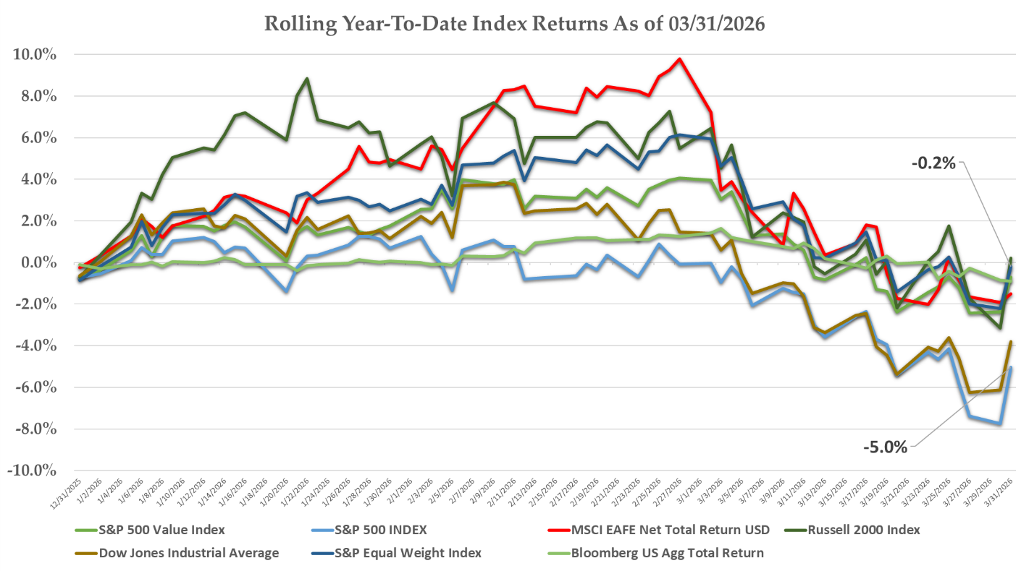
Source: Bloomberg
First Quarter Stock Performance

U.S. stocks were flat through the first two months of the year while displaying many of the broadening trends that characterized the closing months of 2025. The Magnificent 7 basket of stocks underperformed sharply through February, as both Microsoft and Amazon quarterly earnings failed to meet lofty investor expectations and investors were spooked by an acceleration in their already historic capital expenditure plans. The AI trade turned into a net negative for stocks during the quarter, with a diverse group of traditional industry leaders suffering historic single day declines due to fears of AI disruption. IBM dropped more than 13% in a day after the AI platform Anthropic launched a tool to modernize legacy COBOL computer code, threatening its profitable legacy business. Brokerage platform Charles Schwab dropped 7% on the headline of an AI platform launching a wealth planning tool. Market data vendors, internet security providers, and software companies all sold off sharply during the quarter on AI fears. Investors rotated into dividend paying and defensive strategies with health care, real estate, and consumer staple stocks leading the market.

This trading pattern reversed following the outbreak of hostilities with Iran. Financial and Tech stocks lead the overall market through March while rate-sensitive, safe-haven stocks underperformed. At quarter end, the S&P 500 Index declined approximately 4.4%. Energy stocks were the clear winner, advancing 38% in the period. Even with their March rally, Financials, Technology, and Communications stocks trailed market returns.

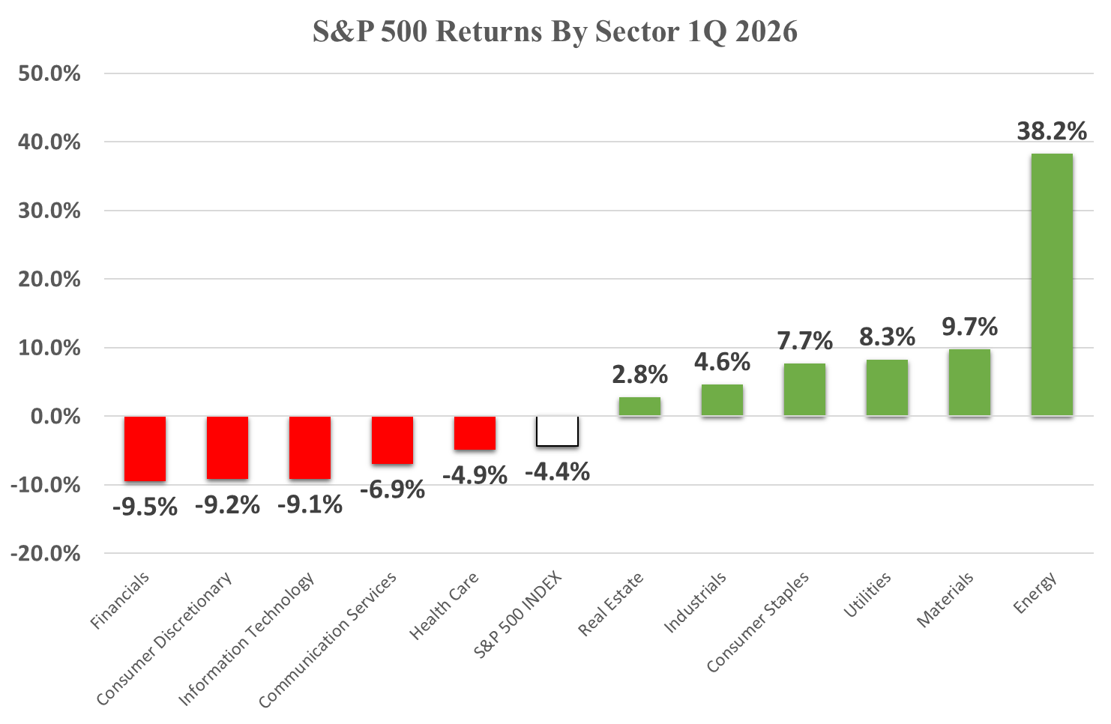
Source: Bloomberg

International markets posted even greater reversals in March. Developed and emerging markets posted double-digit gains through the end of February but swung to losses by quarter end. The greater dependence of Asian and European economies on Middle Eastern oil provided them much less flexibility to weather the sudden commodity price shock. Many oil producing emerging markets in the Middle East saw their output drop noticeably due to damage to production infrastructure during the conflict.
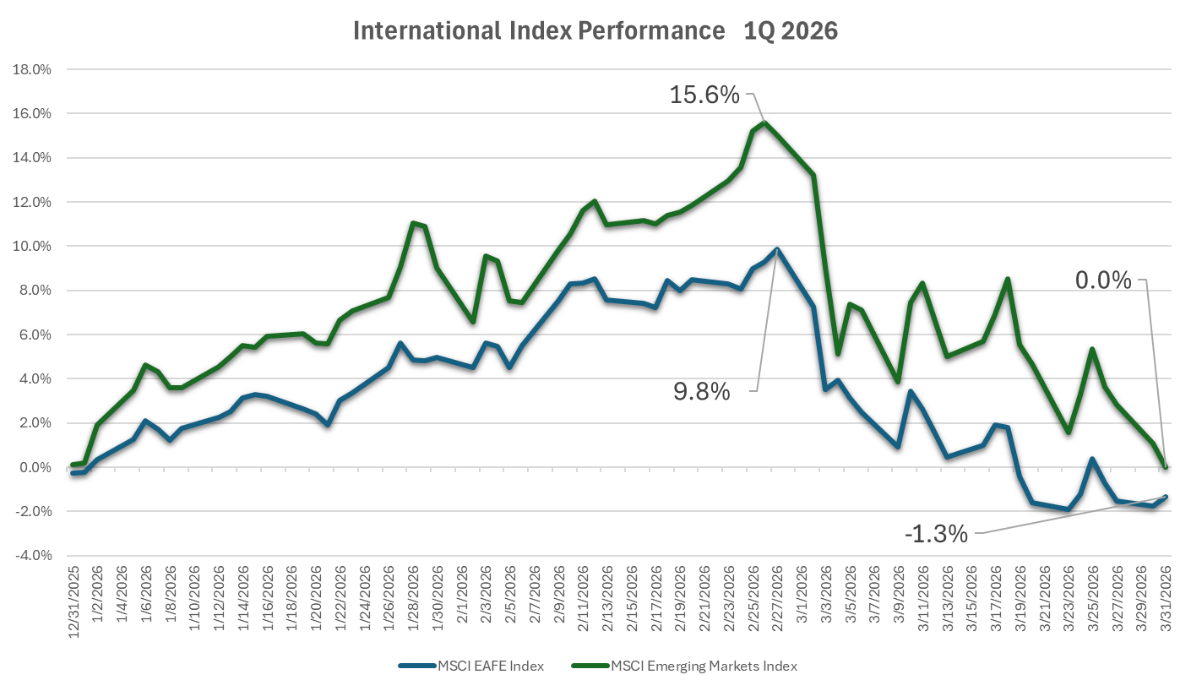
Source: Bloomberg

Fixed Income Markets

The Iran conflict ended the multi-quarter trend of a steepening Treasury yield curve, with the two-year bond yield spiking during the quarter. Intermediate and longer term rates also rose but remained relatively stable compared to shorter maturity yields.

Source: Bloomberg, Turtle Creek Trust Research

Short-term Treasury yields had traded down for several quarters due to moderating economic data and a dovish incoming Federal Reserve Chair nomineee, Kevin Warsh, who has publically called for immediate rate cuts. The inflationary implications of commodity price spikes during the quarter quickly extinguished most wagers on declining rates. At the beginning of the year, futures markets were pricing at least two Federal Reserve cuts by year end and a 60 basis point reduction in the Fed Funds rate. At quarter end, markets were predicting no Fed cuts for 2026 while some analysts discussed the need for Fed hikes to deal with resurgent inflation.

Treasury yields rose slightly across all of the yield curve, while credit spreads for corporate bonds remained largely unchanged for the period. This transalted to small losses for longer-term bond indices and marginal gains for shorter-term maturities.
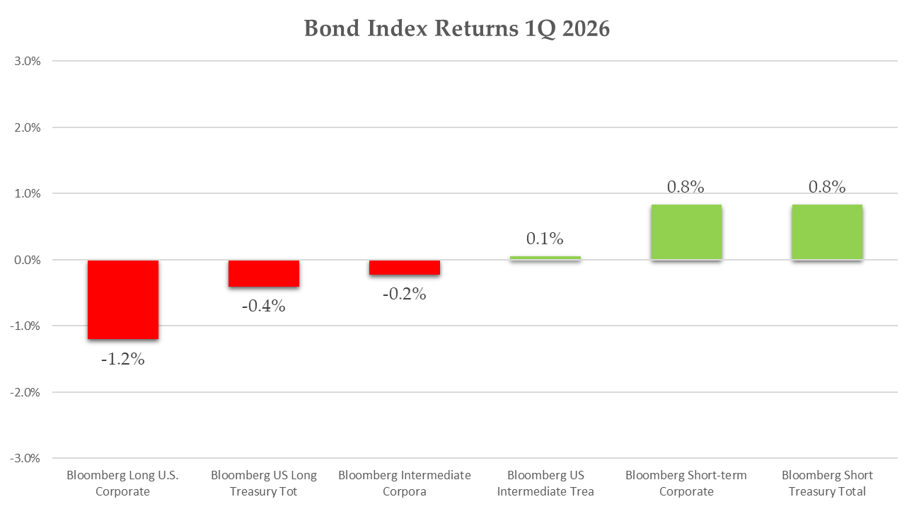
Source: Bloomberg

A Muted Market Reaction to the Iran Conflict

The factors cited in this letter - single-digit losses for stocks, flat bond returns, and stable credit spreads - strike Turtle Creek as very mild reaction to a major geo-political event. Previous Middle Eastern conflicts such as the First Gulf War in 1990 sparked a near 20% drawdowns in U.S. stocks and much greater handwringing over the recessionary impact of disruption to Middle Eastern energy supply.

Looking beyond real-time indicators, investors seem even more unfazed by recent events. Technical indicators were largely stable through March, with gauges such as the VIX jumping slightly but remaining well below historical readings showing true market panic. 12-month inflation expectation surveys did jump after the outbreak of conflict, but longer-term surveys did not budge, showing investor beliefs that any disruption will be transitory. Futures markets are also predicting short lived pain, with West Texas Intermediate Crude Futures currently predicting a significant decline in oil prices by year end.

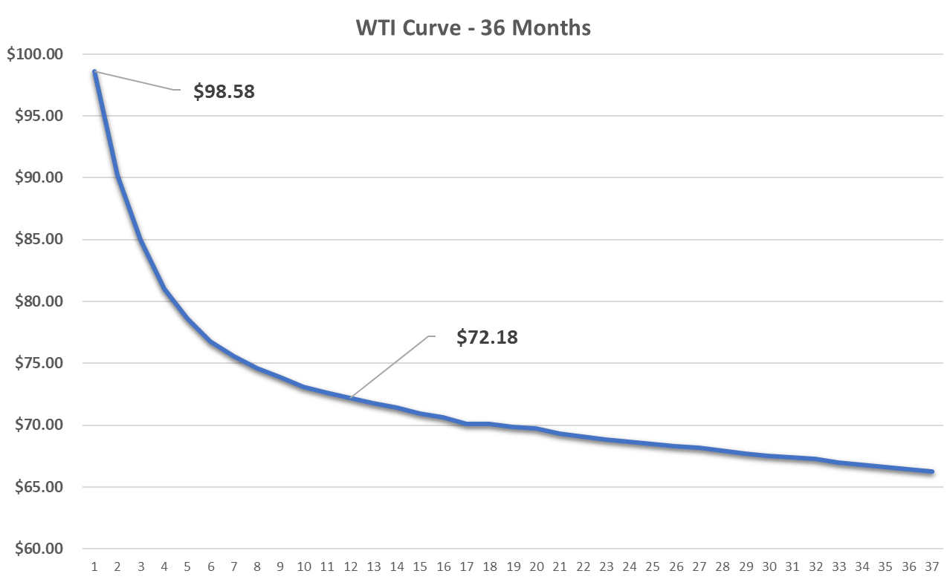
Source: Bloomberg
Investment Strategy

Turtle Creek Trust views the many market-related risks that we have highlighted in our recent letters as still relevant. Valuations remain historically rich across the many economic sectors while headwinds remain for near-term economic growth. With this backdrop, we continue to deploy our “bear market playbook” of fully funding near term obligations, maintaining portfolio diversification, and selectively taking profits in near term winners.

We don’t view investors as irrational in betting on a quick resolution to the current conflict. The Trump Administration has shown a willingness to back down quickly from brinksmanship on many economic and foreign policy matters, and this episode may be no different. We do not view the market as adequately discounting a scenario of prolonged hostilities and sustained increases in commodity prices and expect risk markets to react negatively should that scenario unfold.

Our cautious tone in this letter is not a unique view. The Investment Company Institute estimated total money market funds held by investors at $7.8 Trillion at quarter end, a historic high that has grown by 75% since 2022. While this is partly explained by more attractive yields on cash, it also displays the current hesitance by investors everywhere to fully embrace the longer-term rewards of equities.

All this being said, the overall market’s mild losses have masked severe dislocations in many sectors, and our research process is identifying an increasing number of attractive long-term opportunities for your portfolio. We plan to be active in adding to your portfolio incredible businesses that trade at an appropriate discount to intrinsic value.

Long-term interest rates should continue to be pressured by elevated inflation expectations while we expect shorter maturity yields to trade on news flow. A quick curtailment to the Iran conflict will likely reverse recent the spikes in short term rates. With this setup, and considering historically slim credit spreads, we favor a short duration, high credit quality bond strategy.

Finally, we encourage our clients to look through near-term events and maintain buy and hold discipline. Markets have powered through much more dire circumstances historically, and we have not lost faith that they will provide your portfolio with rewarding outcomes in the future.

Please note that we have included several of our regulatory filings with this message for your review. We look forward to discussing these points and any other questions or concerns with you soon.

Sincerely,

TURTLE CREEK TRUST

“Turtle Creek Trust Company, LTA, is a chartered trust company registered with the State of Texas. Turtle Creek Management, LLC, is an investment adviser registered with the United States Securities and Exchange Commission. Turtle Creek Management, LLC, is not a chartered bank, trust company, or depository institution. It is not authorized to accept deposits or trust accounts and is not licensed or regulated by any state or federal banking authority. Turtle Creek Trust Company, LTA, and Turtle Creek Management, LLC, are wholly owned subsidiaries of TCTC Holdings, LLC, which together operate under the assumed name Turtle Creek Trust.”

