April 2025

Dear Turtle Creek Client,

In this letter, we depart from our standard approach of summarizing results and spotlighting key themes from the prior quarter. The Trump Administration’s “Liberation Day” trade policy, unveiled just two days into the second quarter, rendered most every first quarter datapoint irrelevant while ushering in an entirely new set of forward-looking risks for your portfolio. Given the unexpected and historically extreme nature of the White House’s tariff measures and the sharply negative reaction by most every risk market around the world, we find it better to diagnose the issues at hand while plotting a path through this new and much more treacherous investment backdrop. Gone are prior concerns over exuberant stock valuations in certain corners of the stock market, the potential rekindling of inflation, and the uncertain outlook for the shape and level of the Treasury yield curve. The real-time market reaction to these new trade policies reflects quickly mounting concerns that, absent a quick course change by the White House, global recession and even “stagflationary” scenarios could unfold over the near-term.

For the third time in the last five years, Turtle Creek Trust is urging you to stick to a now well-worn bear market playbook. Investors are best served at moments like these by analyzing near-term financial needs, maintaining buy-and-hold discipline, persevering through market fluctuations, and ultimately stepping into attractive discounts to intrinsic value that often only materialize during periods of market strife. Just as in the recent COVID market collapse, the Global Financial Crisis, and other periods of dauntingly negative near-term prospects; we believe investment markets will eventually reward those who stay the course with an eye to the long-term.

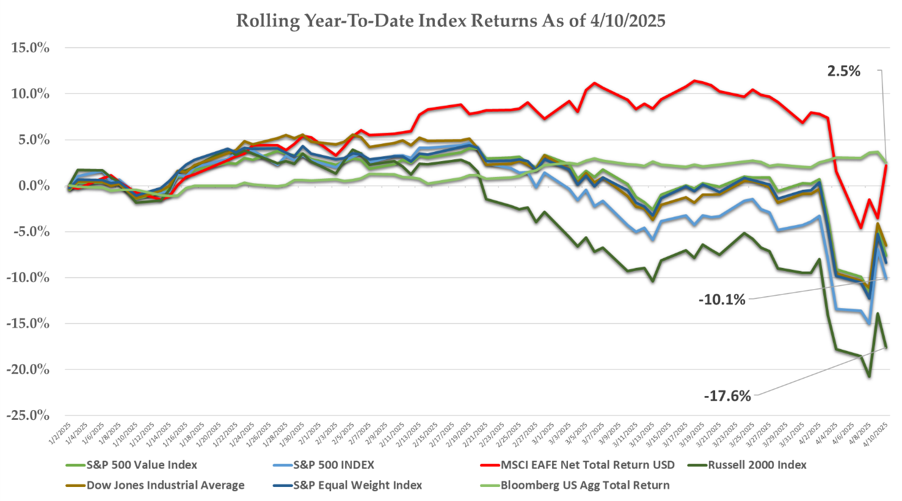
Source: Bloomberg
First Quarter Stock Performance

U.S. stocks were already wobbling through the first quarter as investors became increasingly worried about the sustainability of Artificial Intelligence spending and softening economic data that hinted at an economic slowdown. Sector, style, and capitalization analysis at the end of the first quarter all displayed typical pre-recessionary jitters with defensive sectors leading the overall market, low volatility stocks outperforming cyclicals, and smaller-capitalization companies posting market leading losses.

Health Care, Consumer Staples, and Utilities posted solid gains while the formerly high-flying technology and communications sectors posted double-digit losses. The formerly unstoppable “Magnificent 7” stocks spanning Apple, Alphabet, Amazon, Microsoft, Meta Platforms, Nvidia, and Tesla dropped nearly 20% from their early January peak by quarter-end.

The S&P 500 in aggregate posted a 4.2% decline for the quarter while the Russell 2000 Index, the standard proxy for smaller companies, posted a 9.5% loss.

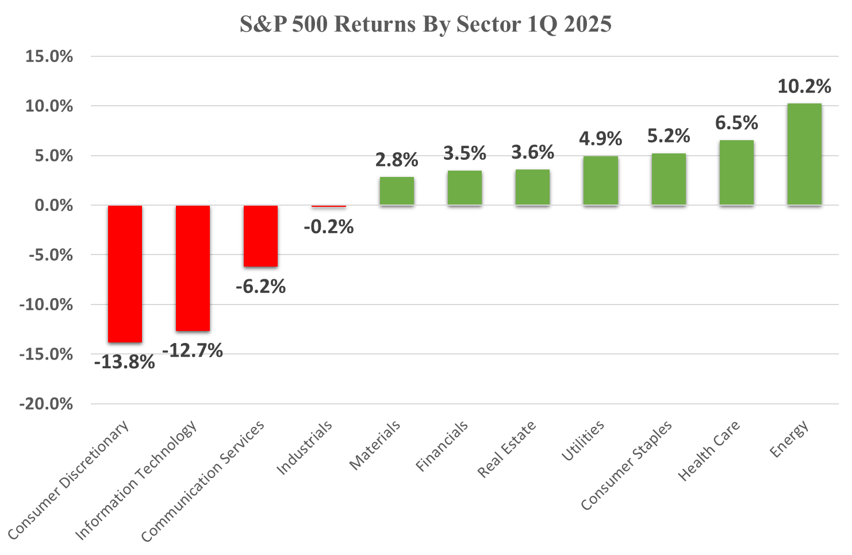
Source: Bloomberg

International markets posted much stronger results through the first quarter, particularly in China and the Eurozone. Chinese shares rallied primarily due to improving economic fundamentals but also due to a formerly unknown tech startup named DeepSeek shocking the Artificial Intelligence industry in January. Its R1 Chatbot model rocketed to the top of global app downloads, surpassing OpenAI’s ChatGPT and doing so utilizing a much more cost-efficient development process. This disruptive shift in AI model development lifted most Chinese tech stocks through the quarter.

The Trump Administration’s shift in support for Ukraine in its military conflict with Russia and its general criticism of the NATO defense alliance resulted in several significant policy shifts in the European Union. Incoming German Chancellor Friedrich Merz won a vote in the German Parliament that allowed a huge increase national borrowing to fund defense spending. Similar initiatives were put forth in Italy, France, and other EU nations with the European Union itself putting forth the “ReArm Europe” plan focusing on defense readiness through 2030. This planning document envisioned up to EUR 800 billion in incremental defense spending. These policy plans marked a notable shift away from austere budget measures of Eurozone countries over the last ten years and raised hopes for revitalized economic growth throughout Europe.

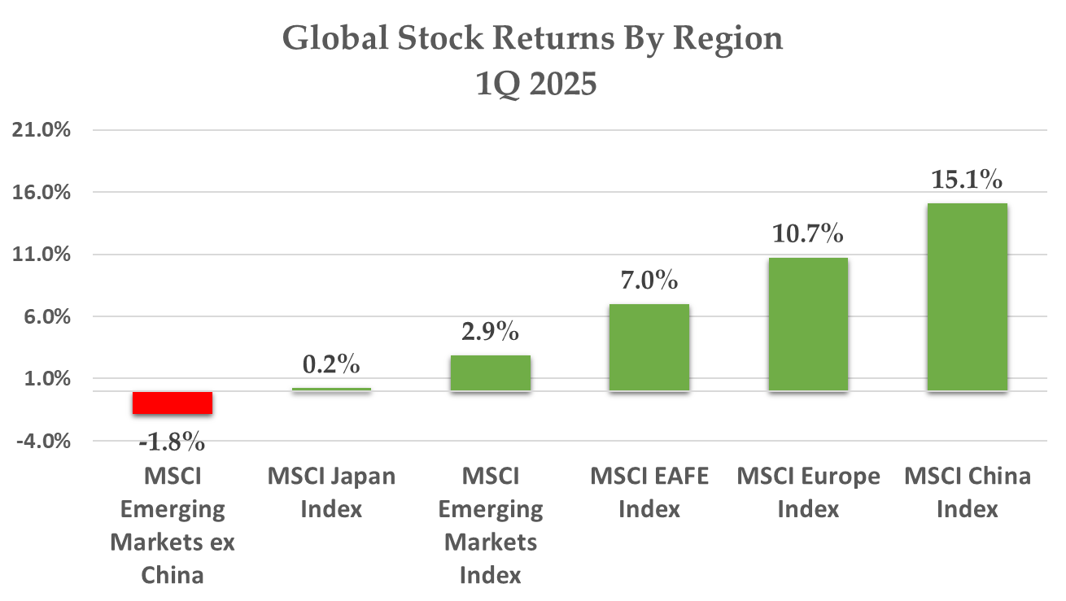
Source: Bloomberg

Fixed Income Markets

Bond yields retreated through most of the first quarter as new economic reports displayed the first proof that recent declines in consumer and business sentiment were translating into an actual cooling of economic activity. Consumer spending and retail sales flat-lined during through much of the quarter while Industrial indicators such as durable goods and factory orders unexpectedly declined. Business services also slowed noticeably though the end of February.

Economic activity did rebound through March but many economists explained those figures away as accelerated purchases by consumers looking to avoid the eventual negative impact of tariffs. Industry groups noted abnormal spikes in auto sales, personal computers, and appliances through the end of the quarter. Business inventories also rose noticeably as managers stockpiled lumber, tools, and other items in advance of cost increases or supply disruptions. The most dramatic moves were seen in raw commodities such as copper, which saw its spot price soar nearly 26% as manufacturers aggressively stockpiled reserves of key industrial metals. Fixed Income traders largely agreed with the transitory framing of March business activity, as the 10 Year Treasury sagged sixty basis points from January through end of the quarter, finishing at 4.2%

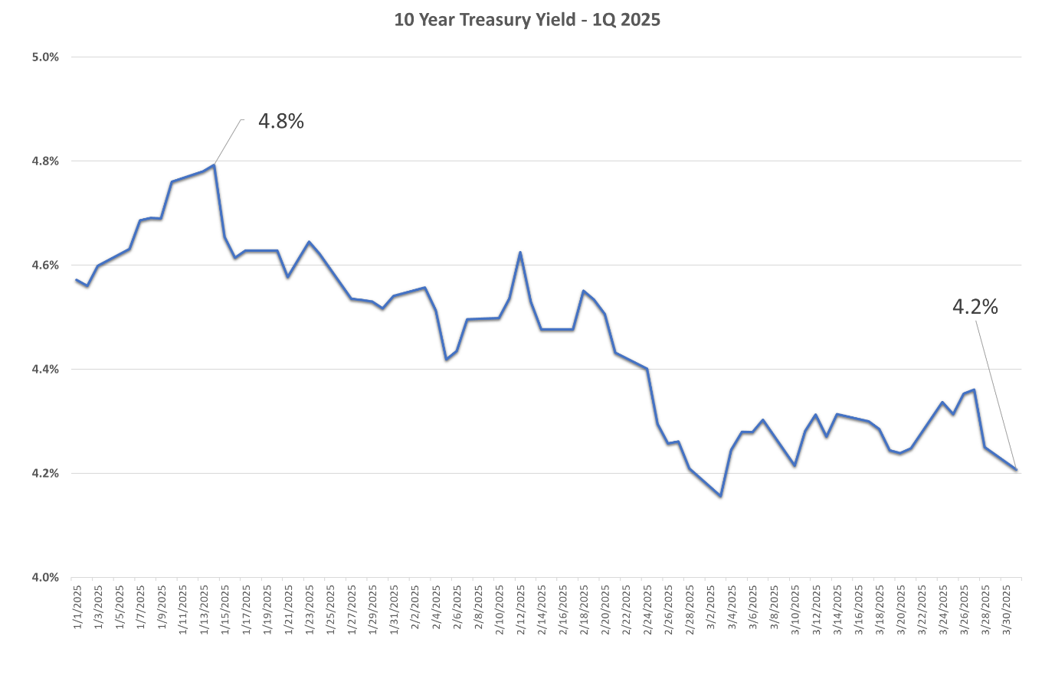
Source: Bloomberg

“Liberation Day” by the Numbers

The Trump Administration’s deployment of aggressive trade measures was a surprise to no one given their central role in his latest electoral campaign and his long history of rhetoric on this subject. Because of this, market analysts had been factoring in varying degree of near-term stress to corporate profits throughout the first quarter. The consensus outlook anchored on the likelihood of some degree of “reciprocal tariffs”; tit-for-tat levies meant to induce negotiations towards lower trade barriers.

The plan unveiled in the White House ceremony on April 2nd far exceeded even the most bearish of market expectations, however, while the design and ultimate purpose of the new plan mystified trade economists. The actual Liberation Day plan levied a minimum 10% tariff on every foreign trading partner and targeted a specified list of 57 nations with much harsher tariff rates ranging from 50% on the small African nation of Lesotho, home to outsourced textile manufacturing, down to 11% for the Republic of Congo. The intellectual basis for these differing levees was not apparent, with many analysts vainly attempting to develop formulas that might explain the rationale for the various targets. In total, economists estimate new all-in U.S. tariff rates on imports in excess of 22% per Fitch Ratings Group, nearly ten times greater than last year’s level of 2.3% and higher than even the now reviled Smoot Hawley Tariff Act of 1930, which the U.S. Senate describes on its website as “among the most catastrophic acts in congressional history.”

The Trump Administration hailed its plan as the only economic medicine that could radically re-shape global trade flows, rebuild U.S. manufacturing, and increase jobs at home. It did not put forth expected timelines or the criteria that constituted success for its new trade stance, instead offering more generic claims of “strengthening the country”, “leveling the playing field”, and “increasing our competitive edge.”

While White House officials made great efforts to spin the advantages of its new plan, the historical effects of tariffs are fairly well-researched, and the likely impacts of the new Trump trade plan were analyzed through those lenses.

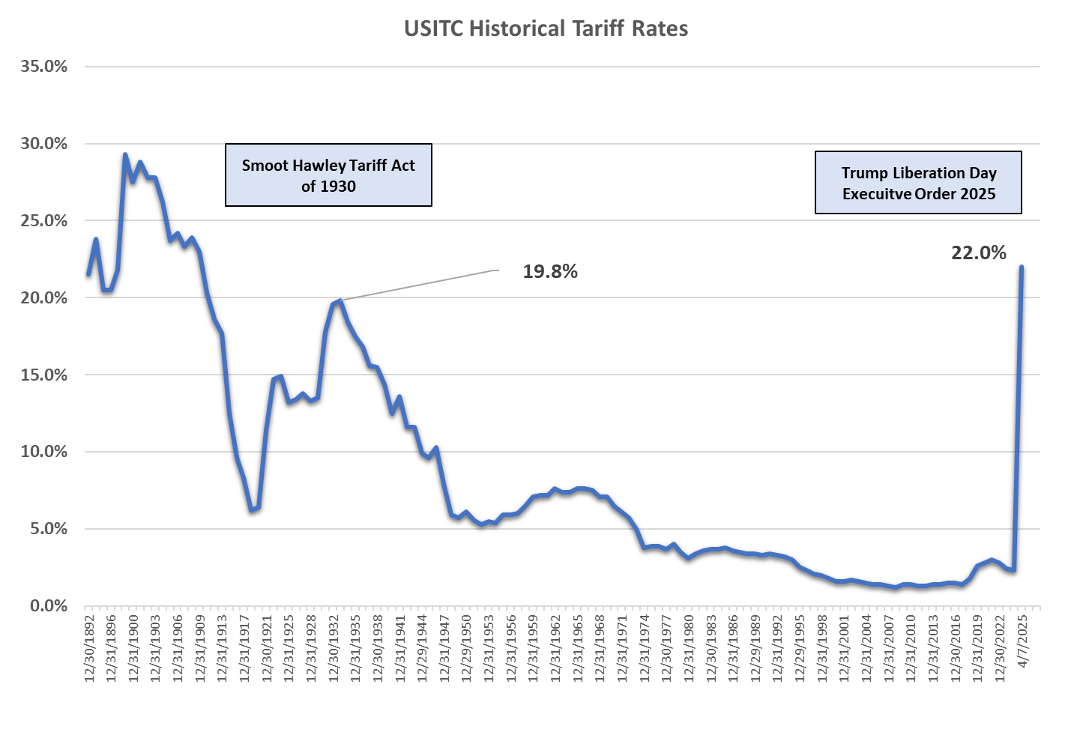
Source: Bloomberg, U.S. International Trade Commission

Economic research concludes that tariffs inflate cost-structures, spur inflation, reduce demand, and negatively impact business confidence. The Trump plan should result in significant incremental cost for offshore manufacturing of everything from consumer electronics to automobiles, which implies margin pressure for U.S. corporations and the likely passing of these new costs to consumers through higher prices. Input costs for domestic agriculture, homebuilding, and manufacturing will leap under the new Trump plan. U.S. exporters also now face retaliatory tariffs imposed by most foreign markets. Businesses facing an uncertain near-term future have historically pulled back on capital expenditures and hiring, a trend likely to reoccur in the months ahead.

Condemnation of the plan was therefore swift and, outside of a small handful of labor unions, nearly universal. Ardent Trump supporters like well-known hedge fund manager Bill Ackman lambasted the plan as crude, destructive, and disproportionate. JP Morgan Chase CEO Jamie Dimon said that the Trump plan would spur inflation, hobble an already slowing economy, and weaken America’s standing in the world. Conservative Republican Senators ranging from Ted Cruz to Rand Paul openly criticized the plan, noting that tariffs are a tax on consumers and the scale of the Trump trade plans would be both economically and politically destructive and called for the tariffs to be rolled back quickly.

Market Reaction

Market reactions to the new trade plan were both extreme and volatile, reflecting the Black Swan like nature of the sudden shift in the economic outlook. Stock indexes around the world plunged, initially trading with some logic but eventually tipping over into a general risk-off mode with stocks of all kinds selling off in unison. The S&P notched two of the worst trading days in the last 30 years, sinking 4.8% and 6% on back-to-back days.

The reactions of the bond and currency markets were more concerning, however reflecting stresses in the basic functioning of the Treasury and U.S, Dollar markets. Both traded in patterns contrary to the usual safe haven status of those of asset classes as intermediate and longer-term Treasury bond yields spiked and the dollar declined against major currencies. This hinted at forced selling of U.S. bonds and was reminiscent of the extreme dislocations experienced at the height of the COVID market panic in 2020.

The extreme and universally negative reaction, particularly in the bond market, seemed to force a shift in the White House’s plans with President Trump announcing a 90 delay in implementation of trade measures. This news resulted in a historically extreme market rebound. U.S. Indexes soared nearly 10% in response, the third best single trading day since World War 2.

Investment Strategy

We have always stressed portfolio management best practices in these quarterly notes and many of these rules bear repeating at this juncture. Firstly, remember the signal-to-noise ratio. Do not try to find value or certainty in any recent market reaction or revised near-term forecast as most data is most certainly noise. The very best minds in corporate management and Central Bank policymaking have said they cannot handicap with confidence the near-term impact of recent events, so the team at Turtle Creek or the individual investor should refrain from doing so as well.

We have discussed the importance of scenario-based planning, and thinking through potential future outcomes hints at scenarios ranging from mildly negative should the Trump team completely unwind its trade stance over the next few weeks to truly recessionary if trade hostilities remain in place. We cannot dispute the analysis regarding the impact of trade levees of this scale. We also believe that inherent business uncertainty places a brake on the corporate investment that fuels value creation and stock market gains.

Another complicating factor is the uncertain likelihood of Central Bankers riding to the rescue through aggressive rate cuts. The Federal Reserve Board has a dual mandate to maintain both maximum employment and price stability. The inflationary implications of the Liberation Day policies hint at potentially “stagflationary” outcomes, i.e. inflation rises while economic activity declines. Fed Chair Jerome Powell noted as much in his first comments since the unveiling of the Trump trade plans, saying this policy shift hints at sustained increases in inflationary trends over the longer-term. The lessons of stagflationary periods like the late 1970s and early 1980s show that the Fed will maintain rates at punitive levels to squelch inflation no matter the cost to the economy, so investors should not place any confidence in immediate economic support from the Fed.

So with uncertainty high, markets volatile, and no apparent near-term catalyst to improve sentiment, we urge you to follow the Bear Market playbook. The most important first step in this plan is to clarify any planned portfolio withdrawals over the next 12-24 months and make sure they are adequately reserved for no matter the behavior of markets over the near term. Behavioral finance analyzes the concept of Anchoring Bias, showing that investors often display an irrational tendency to fixate on datapoints such as 52 Week high prices or recent trading peaks when making decisions. Even with the volatility of the last week, year-to-date losses remain fairly mild, and you have a clear window to shift portfolio holdings at this moment for any unreserved withdrawals. Some of the greatest investment mistakes are forced sales of risk assets at moments of maximum market stress, so take steps now to avoid such an outcome.

One of the other great mistakes made by investors is retreating to the sidelines during moments of extreme market volatility. We have illustrated in prior notes how longer-term market outcomes are heavily dependent on a relatively small number of extreme trading days, and those days are often clustered closely together. Investors that sell out of markets after extreme days and miss subsequent rebounds permanently undermine the long-term rewards realized in equity markets. These last seven days were a great reminder, featuring both historically negative and positive trading sessions within a single week. Persisting through this volatility was the right plan and will continue to be in the months ahead.

Best and Worst Market Days Since 1975

Source: Turtle Creek Research

Maintaining buy-and-hold discipline though market downdrafts has historically been the most rewarding strategy, and we see no reason this will change now. As illustrated in the attached historical chart, markets have compounded through far worse circumstances. Malfunctioning economic policies come and go and bubbles inflate and collapse but the compounding power of the market continues over the long haul.

Finally, we do want to be on the offensive as attractive valuations emerge on world class companies. We have already seen more attractive discounts to intrinsic value emerge on many leading companies we have previously avoided due to extreme valuation. We cannot guarantee you we pick the bottom for any of these securities, but we do add these investments knowing they represent excellent longer-term opportunities for your portfolio.

As always, we hope to discuss these points and any other questions or concerns with you in the weeks ahead. Please call or write with any questions.

Sincerely,

TURTLE CREEK TRUST

.

“Turtle Creek Trust Company, LTA, is a chartered trust company registered with the State of Texas. Turtle Creek Management, LLC, is an investment adviser registered with the United States Securities and Exchange Commission. Turtle Creek Management, LLC, is not a chartered bank, trust company, or depository institution. It is not authorized to accept deposits or trust accounts and is not licensed or regulated by any state or federal banking authority. Turtle Creek Trust Company, LTA, and Turtle Creek Management, LLC, are wholly owned subsidiaries of TCTC Holdings, LLC, which together operate under the assumed name Turtle Creek Trust.”

