July 2025

Dear Turtle Creek Client,

Global markets began the second quarter in a tailspin, reeling from the shock news of the Trump Administration Liberation Day Tariff plan. Subsequent events added even more confusion to the macroeconomic and geopolitical backdrop, with open war breaking out in the Middle East and Congressional budgetary plans amplifying U.S. deficit concerns. New economic data was largely negative during the quarter, displaying downward revisions in earnings forecasts, declines in gross domestic product and consumer spending, and depressed consumer sentiment readings. Despite all these headwinds and uncertainties, global stock markets delivered a powerful and steady recovery from their lows of early April, with the S&P 500 index reaching new highs by quarter-end and international markets sustaining outsized performance year to date. The robustness of the recovery flummoxed most market analysts, resulting in a wide-ranging debate as to just why investors remain bullish in the face of ongoing and elevated risk.

The investment team at Turtle Creek Trust acknowledges that the very worst does seem to be past due to the Trump Administration’s quick walk-back of the most draconian trade measures that shocked markets in early April. We do remain mindful of the many risks that remain, however, while being less enthusiastic about market valuations after such a strong rebound in asset prices. We have urged you to deploy a bear market playbook in light of recent events and, even though many markets never reached bear market territory and have since rebounded, we think that stance remains the best one at the current juncture. Investors should use the recent market recovery to rebalance back into their investment plan, trim winners that looked overvalued, and fund any near-term obligations while markets remain in an optimistic mood. The current mix of anxious consumers, slowing business investment, and still-elevated uncertainty could still stoke market volatility in the second half of the year.

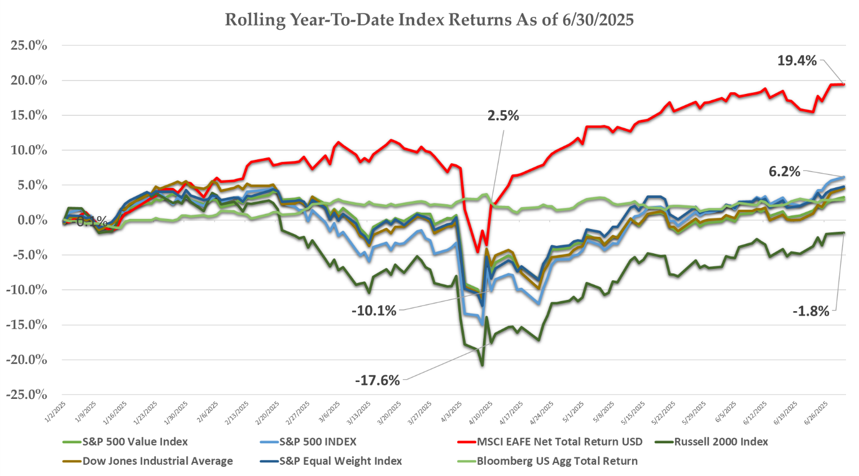
Source: Bloomberg
Second Quarter Stock Performance

U.S. stocks advanced approximately 12% in the quarter, with most economic sectors posting positive gains. The Artificial Intelligence trade returned to prominence during the period, recovering quickly from its first quarter swoon and driving both the Information Technology and Communications sectors to market leading gains. Industrial stocks also outpaced the market, as defense companies rallied on increasing Middle Eastern conflict and Aerospace and Manufacturing firms posted strong earnings.

Energy, Health Care, Real Estate, and Consumer Staples stocks were market laggards. Health insurers and pharmaceutical companies suffered from heightened regulatory concerns and the potentially negative impact of Medicare and Medicaid reimbursement cuts in the latest congressional budget bill. Energy stocks reacted negatively to declining commodity prices as global oil producers continue to build excess supply while demand remains muted.

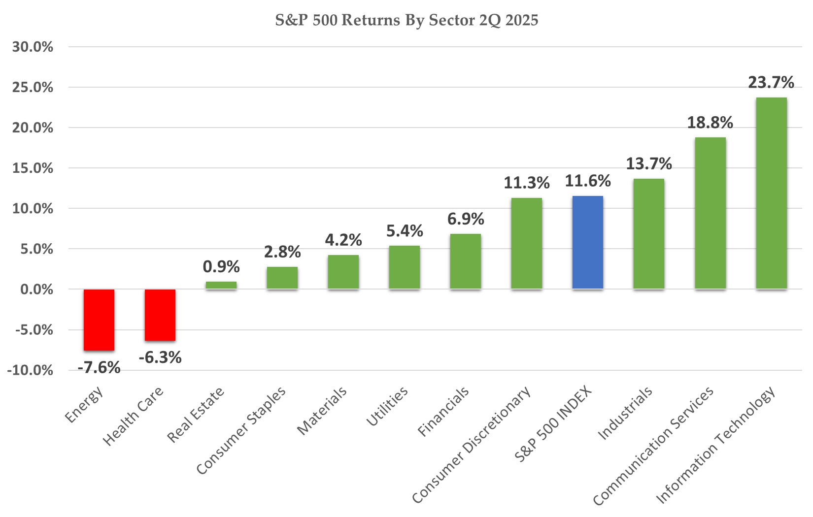
Source: Bloomberg

One noticeable trend in the quarter was the increasing divergence between the “Magnificent 7” stocks that for many years carried the market higher in lockstep and the general Information Technology and Communications sectors, where leadership has gravitated to new firms benefiting from the ongoing buildout of Artificial Intelligence Infrastructure.

While Nvidia, Microsoft, and Meta Platforms (Facebook) have all posted market leading returns and retain critical positions in the emerging artificial intelligence landscape, the four other members of this group – Apple, Alphabet, (Google), Tesla, and Amazon, have lagged the broader technology index. Tesla shares have declined more than 20% year to date due to plunging global auto sales and fallout from CEO Elon Musk’s contentious relationship with the Trump Administration. Investors have fretted over Apple’s lagging position in artificial intelligence and potential financial stress due to the Trump tariff plan. Alphabet is also fighting investor concern that AI might disrupt its core search business , while Amazon face headwinds to its core retail business under the new Trump tariff plan.

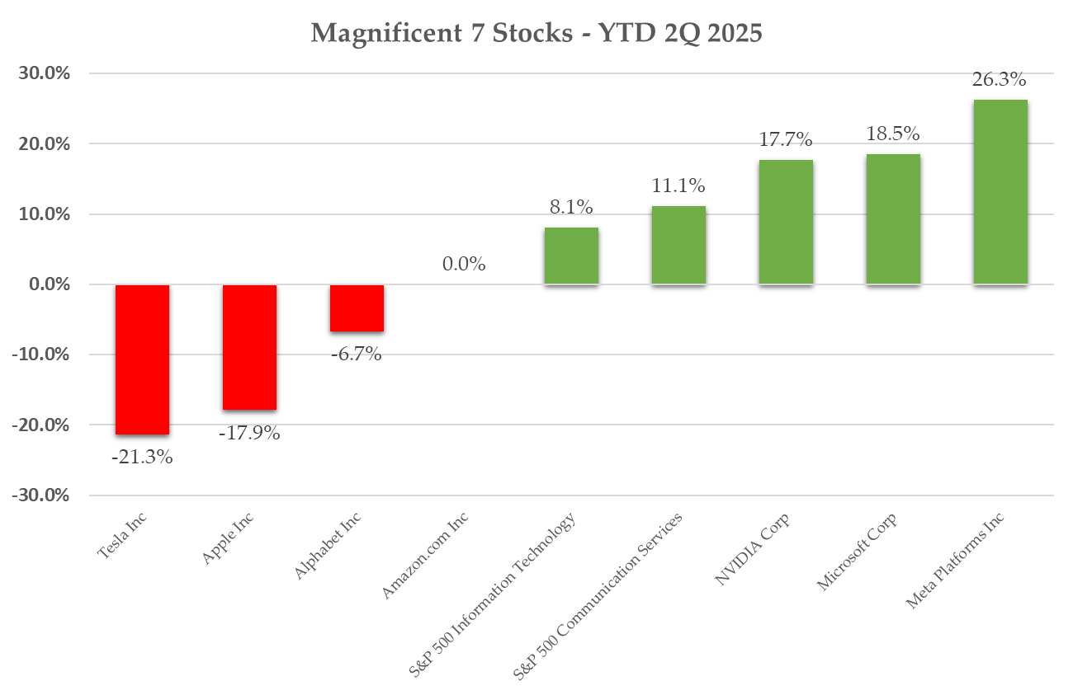
Source: Bloomberg

International markets built on first quarter gains, with almost every global market posting positive results and both emerging and developed markets indexes posting double digit gains. The declining US Dollar helped emerging market returns, while Central Bank rate cuts and a less dour outlook for global trade talks helped EU companies.

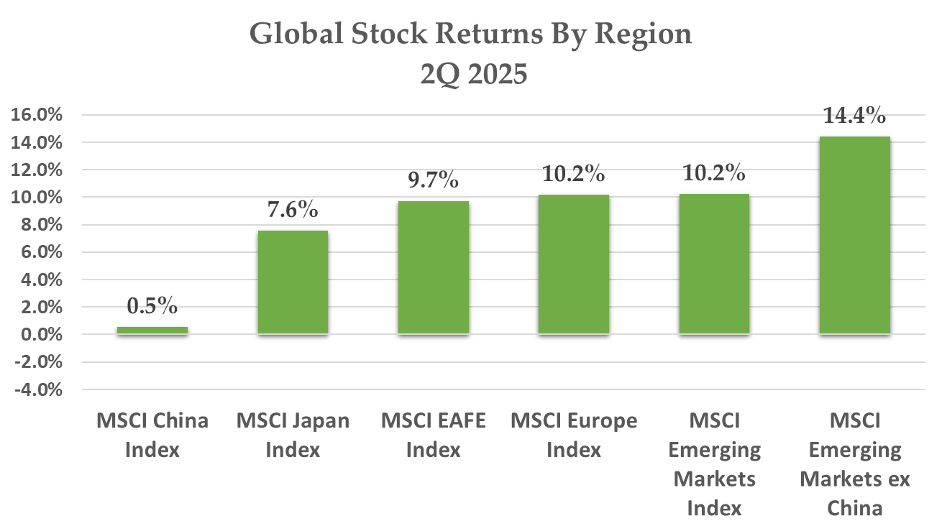
Source: Bloomberg

Fixed Income Markets

Fixed Income markets largely marked time in the quarter. The benchmark 10 Year Treasury yield initially spiked in the wake of the Liberation Day tariff announcement but then declined due to a series of benign inflation reports and a de-escalation in trade rhetoric out of Washington. The 10 Year yield finished the quarter where it started at 4.2%.

The Treasury yield curve did shift during the period, sending mixed messages to bond investors. Intermediate yields declined approximately 20 basis points during the quarter, reflecting increased recessionary fears and a higher probability of Central Bank rate cuts over the next several years. At the same time, longer-dated Treasury yields increased 30 basis points, reflecting elevated concern over the long-term inflationary implications of U.S. Trade policy and also general concern over spiraling U.S. budget deficits.

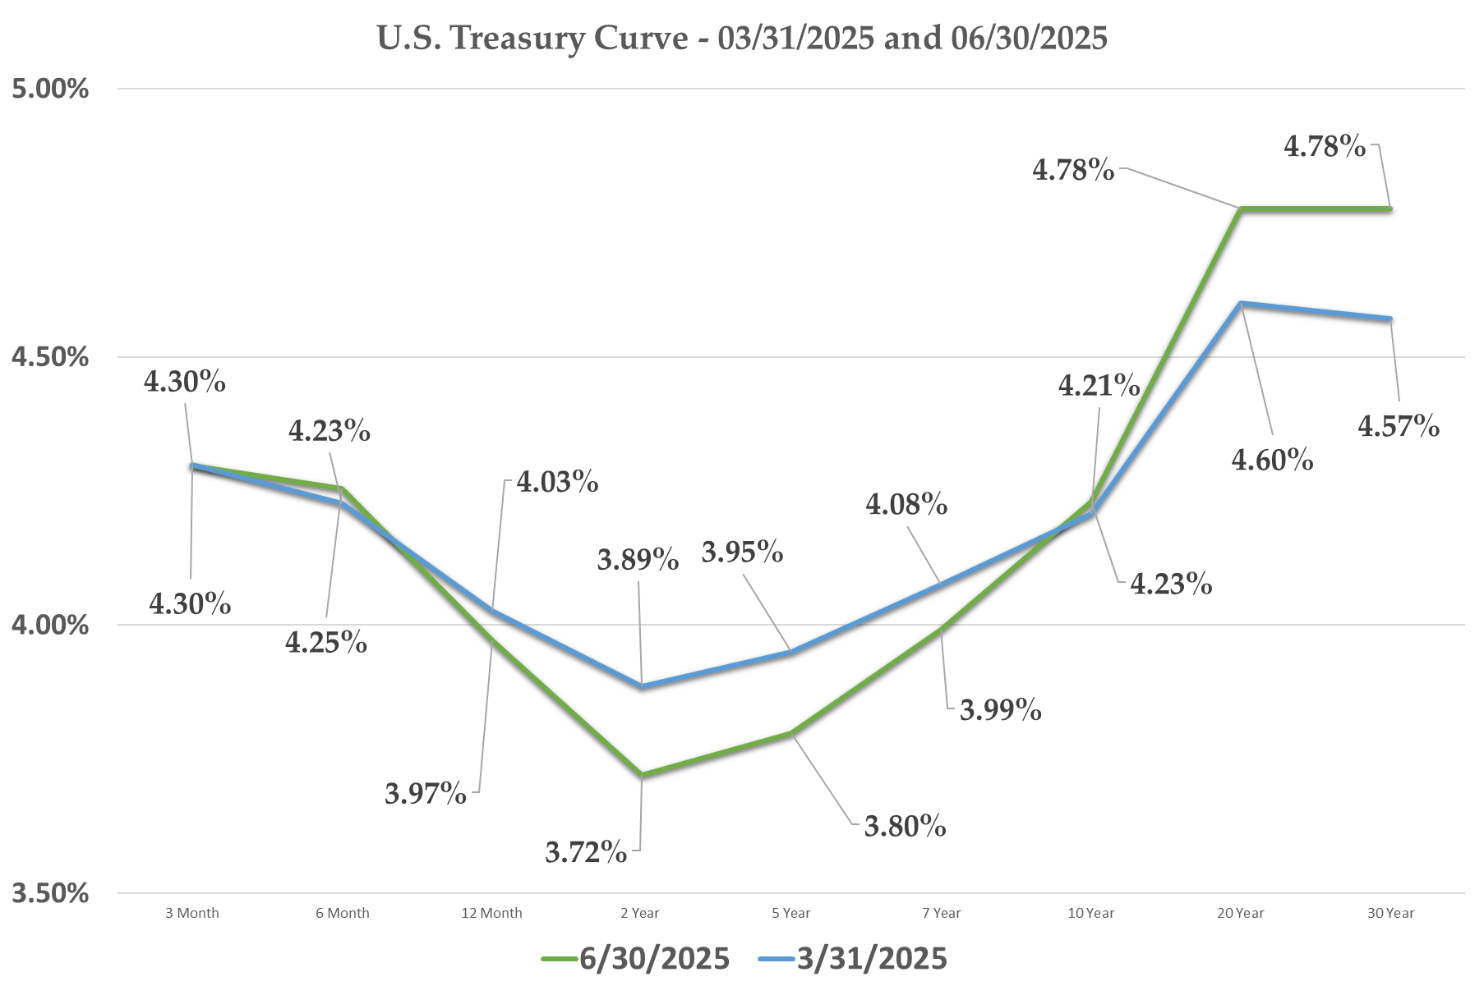
Source: Bloomberg

Liberation Day Tariffs – Results After the Three Months

Investor reaction to the Trump Liberation Day tariff plan morphed through the quarter, beginning as explosively negative, transitioning to apprehensive, and finishing as nearly dismissive. Markets delivered a sharp response to the initial tariff announcement, as stock markets dropped more than 12% in a matter of days, interest rates spiked, and the U.S. dollar plunged. The White House announced a 90 Day pause in response to market upheaval with a pledge to reach deals with 90 key foreign trade during the delay.

Subsequent events provided little clarity on the potential end game of the Trump Administration trade stance. The White House raised tariff rates to 125% on all Chinese goods in April, only to announce a few days later exemptions for a wide variety of critical Chinese imports such as smartphones and electronics. It then enacted a significant reduction in Chinese tariffs in May. Similar episodes occurred through the quarter with several of the U.S.’s largest trade partners. The White House announced 50% tariffs on Eurozone imports starting in June only to delay implementation until July, and then have those tariffs blocked by the U.S. Trade Court. It also announced a significant reduction in tariffs on British goods in May.

This ongoing pattern of large-scale trade threats followed by quick reversals lead Wall Street to introduce the moniker of the “TACO Trade”, or a recommendation to buy any trade-related market dip on the certainty that “Trump Always Chickens Out.” Stocks seemed to ignore trade announcements altogether by quarter end. A June 12th announcement of significant hikes in tariffs on imported steel and aluminum, theoretically a significant threat to manufacturing and industrial profit margins, resulted in no market reaction at all.

As the “90 Deals in 90 Days” time window nears its end, only two draft frameworks have been agreed to with no information available on the timing or probability of final agreements with the remaining 88 key trading partners. The uncertainty of the Trump tariff plans should continue to hang over markets for the foreseeable future.

The Big, Beautiful Bill

The other major economic event of the quarter was passage of the new Congressional Budget, deemed the “Big, Beautiful Bill.” This legislation made permanent previously temporary estate and income tax rates, added in several new tax breaks, and targeted rollbacks of Medicare and Medicaid coverage, SNAP food assistance, and many other federal subsidies.

The bill was a boon for certain industries while punishing others. Significant defense outlays boosted aerospace and defense stocks while bank stocks benefited from funding cuts to several financial regulatory groups, most notably the Consumer Financial Protection Bureau. Clean energy firms were a victim of the bill, which eliminated several tax credits enacted in the Biden Administration for new wind and solar projects. The bill also eliminated individual tax incentives for solar panels and electric vehicles. Health care stocks leveraged to federal Medicare and Medicaid spending all suffered, most notably health insurers and hospital focused real estate investment trusts.

In aggregate, the bill was viewed by analysts as net positive for near-term economic growth and consumer spending. It eliminated pending tax increases built into previous legislation while restoring many recently pared back deductions and introducing several new ones such as exemptions for overtime and gratuity pay and auto loan interest. The bill was viewed as net negative by deficit hawks, who noted the loss of incremental tax revenue far outweighed the cost savings from reductions in federal outlays. The Congressional Budget Office scored the bill as adding an additional $2.4 Trillion to deficits over the next ten years, doubling federal interest costs by 2034, and increasing U.S Debt to GDP to 133% in the worst-case scenario, making the U.S. the third most indebted country in the world behind Japan and Italy.

This mix of short-term gain and long-term pain explained the differing reactions during the quarter by stock and bond markets. Corporate profits are sure to benefit from the fiscal boost in this bill, helping to explain the stock market’s strong run while further strain on the country’s long-term fiscal outlook led to negative returns in longer-dated Treasuries and corporate debt.

Investment Strategy

With the trade situation unresolved and geopolitical concerns still heightened, we expect macro issues to continue to play a historically outsized role in markets over the next several quarters. We had, in our last letter, scoped the potential impact of the Trump Administration’s trade policy as mildly negative should the Trump team completely unwind its trade stance to truly recessionary if trade hostilities remain in place. The quick trade reversals by the White House during the second quarter indicate the mildly negative scenario as the most likely outcome. Even in that scenario, tariffs will still be elevated and likely have their historically proven impact of spurring inflation, reducing demand, and negatively impacting business confidence.

Another unresolved macro-factor is the potential for Federal Reserve rate cuts over the near term. Fed analysts have a very tough job weighing the potentially negative impact of Trump trade policy on future growth and employment and deteriorating macroeconomic data against the inflationary implications of the tariffs. The Fed held rates steady in its most recent meeting, but futures markets are forecasting 50 basis points in cuts to the Fed Funds rate through year end.

The significant rebound in stock markets provides little margin for error going forward. The true impact of Washington policy (if any) on corporate profits has yet to be felt and will become apparent over the next few quarters. Any negative trend in growth or profitability is sure to stoke market volatility.

In terms of fixed income investments, we advocated for many quarters extending durations in your bond holdings but mounting concerns over inflation and increasing bond market skepticism over the U.S. fiscal situation make that a lower probability payoff. Turtle Creek Trust has always treated fixed income holdings as the ballast of your portfolio, and we will continue to make sure your bonds are of appropriate quality and avoid unnecessary rates risk.

Given all of the above, we urge you to stick to the bear market playbook by rebalancing into allocations, funding near term obligations no matter the market backdrop, and stepping into attractive discounts to intrinsic value introduced by market volatility. We hope all of the above comments represent undue caution and the near-term benefits of Federal Reserve cuts, the fiscal boost from the recent budget bill, and the general resilience of the U.S. economy allows stock markets to prosper. We will remain nimble, however, as that process unfolds. For longer-term investors, we continue to urge you to maintain buy and hold discipline as economic history shows markets have endured much more uncertain periods than this one while rewarding investors that stayed the course.

As always, we hope to discuss these points and any other questions or concerns with you in the weeks ahead. Please call or write with any questions.

Sincerely,

TURTLE CREEK TRUST

“Turtle Creek Trust Company, LTA, is a chartered trust company registered with the State of Texas. Turtle Creek Management, LLC, is an investment adviser registered with the United States Securities and Exchange Commission. Turtle Creek Management, LLC, is not a chartered bank, trust company, or depository institution. It is not authorized to accept deposits or trust accounts and is not licensed or regulated by any state or federal banking authority. Turtle Creek Trust Company, LTA, and Turtle Creek Management, LLC, are wholly owned subsidiaries of TCTC Holdings, LLC, which together operate under the assumed name Turtle Creek Trust.”

