October 2025

Dear Turtle Creek Client,

Global markets pushed higher through the third quarter, with both domestic and international stock indices building on year-to-date gains and bond markets posting strong total returns due to declining short and intermediate-term yields. The Artificial Intelligence trade maintained its torrid pace, with headline-grabbing AI infrastructure announcements from leading technology firms driving Artificial Intelligence stocks higher across the board. Small company indexes also participated in the rally, reversing a five-quarter streak of underperforming their large-cap stock peers.

This broad surge in asset prices took place amidst an increasingly complex global economic backdrop. Economic indicators in the U.S. were in general mixed but showed further strain as inflation accelerated, hiring slowed, and manufacturing and service reports missed estimates. Sovereign debt yields spiked in France and the United Kingdom due to worsening deficits and political upheaval. The once impregnable U.S. Dollar continued its historic fall against other major currencies, reflecting the fiscal strain of the recent congressional budget and fallout from the Trump administration’s ongoing trade war. Market analysts dubbed this broad-based dumping of leading global currencies the “debasement trade”, noting an equally historic surge in value for dollar alternatives ranging from cryptocurrencies to precious metals such as gold and silver.

The current mix of exuberant markets and mounting global economic strains keeps us on a defensive footing. We continue to urge investors to raise cash now as needed, be mindful of excess valuations, and book profits as needed to maintain their long-term investment allocation.

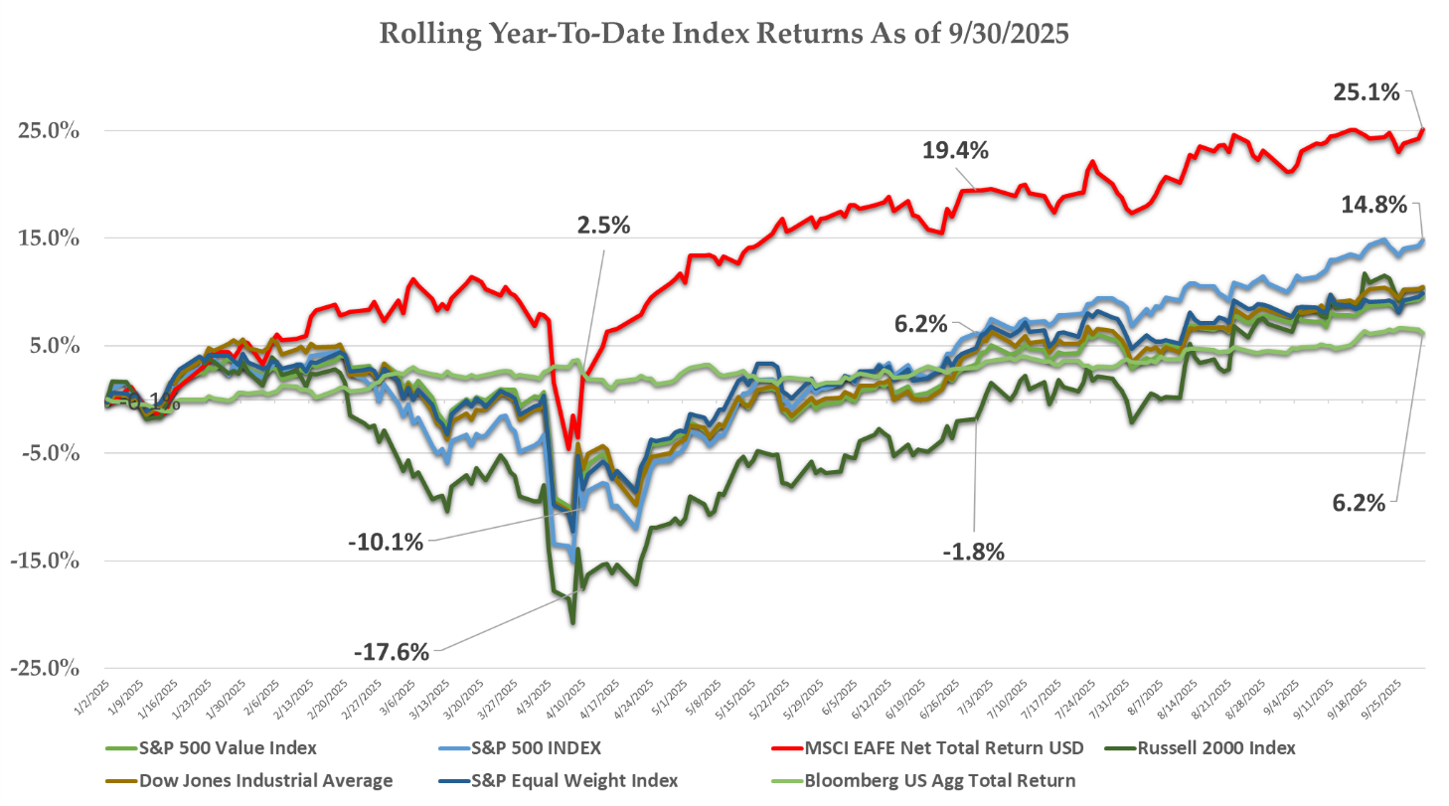
Source: Bloomberg

Third Quarter Stock Performance

U.S. stocks advanced approximately 8% in the quarter, with Communications and Information Technology companies leading the overall market and nearly every other economic sector trailing aggregate market returns. Apple Inc was the largest contributor to index gains, posting a 25% advance during the period as its iPhone 17 release tracked well ahead of expectations. Alphabet Inc. (Google) surged 38% in the quarter, rallying after a federal judge instituted only minor remedies in response to the company’s recent Antitrust conviction. AI related stocks surged across the board, headlined by Oracle corporation’s 36% single day gain after it announced a massive $300 Billion multi-year data center deal with OpenAI. The Bloomberg Artificial Intelligence Index posted a 14% return for the quarter.

Traditionally defensive sectors lagged overall market performance, with Consumer Staple stocks losing ground during the quarter and Health Care stocks posting minimal gains. Both groups have faced significant headwinds from the Trump Administration tariff programs, and Health Care stocks have suffered from regulatory concerns pressuring pharmaceutical and health insurance companies.

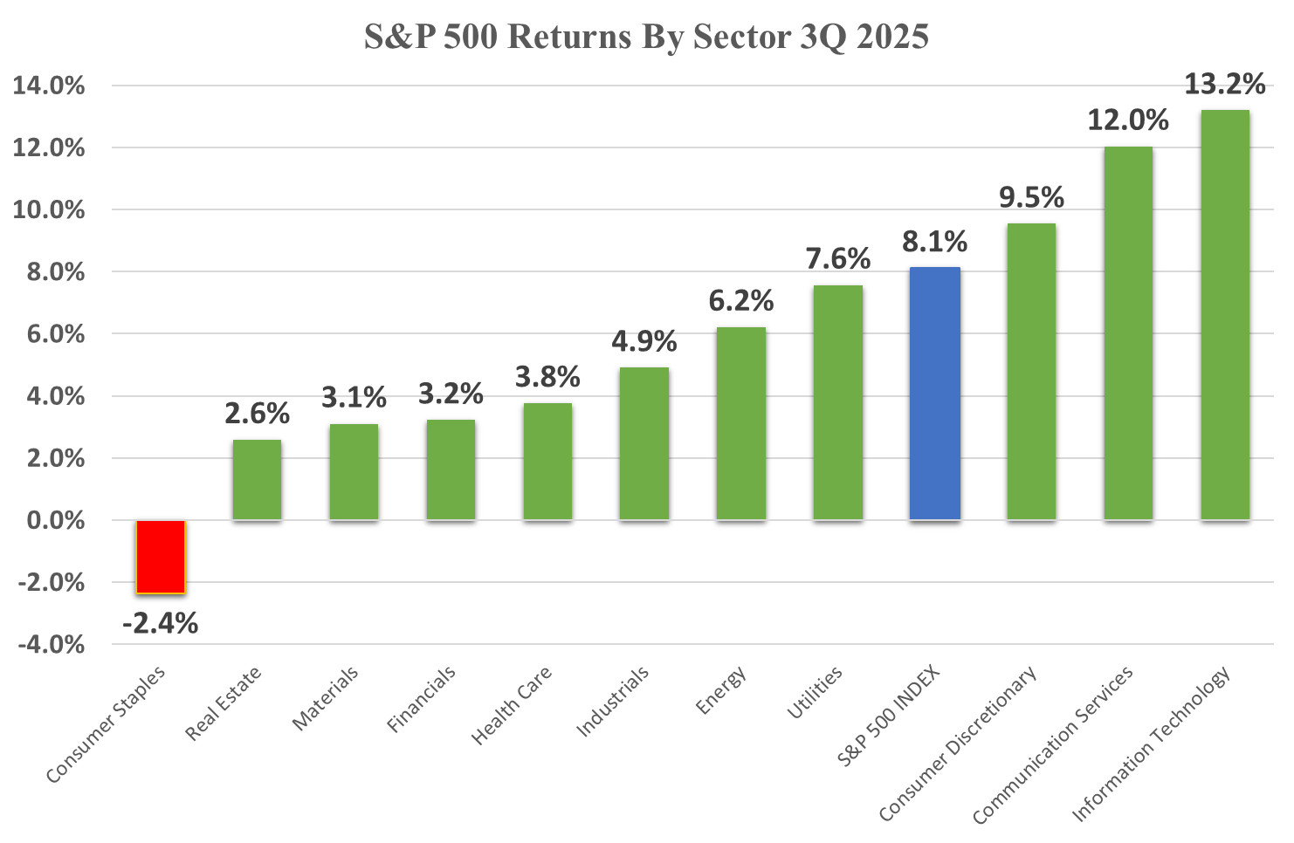
Source: Bloomberg

The narrow, growth-stock-oriented nature of S&P 500 performance during the quarter extended the multi-year streak of cyclical stocks outperforming their defensive peers by a significant margin. For decades, defensive and cyclical strategies traded leadership, with cyclical stocks outperforming during bull markets. Defensive stocks provided much better risk adjusted returns through the final stages of business cycles and bear market downturns. The current stretch of cyclical leadership is reaching its tenth year and, absent any market collapse over the next month, will soon be the longest stretch on record for one style outperforming the other.

Source: Bloomberg, MSCI

Emerging markets stocks, and Chinese shares in particular, lead international market returns as Asian shares were also swept up in the Artificial Intelligence boom. Taiwan Semiconductor, the primary outsourced semiconductor manufacturer for firms ranging from Apple to Nvidia, posted a 24% gain for the period as demand continues to swell for computer chips. China’s leading tech firms also posted strong gains, with the Alibaba Group and Tencent Holdings rising 57% and 32% respectively due to strong cloud computing demand and new AI announcements. The Chinese government, as part of its ongoing trade disputes with U.S., took several steps to block western technologies and support homegrown chip manufacturing, sending most Chinese Tech stocks higher during the period.

Developed international stocks posted solid results despite the political upheaval and fiscal concerns plaguing the Eurozone. ASML Holdings, a Netherlands based supplier of key semiconductor manufacturing equipment, advanced 23% in the quarter as orders surged for its photolithography machines. Softbank, the Japanese technology venture company, led Japanese shares with a 74% gain thanks to its ongoing investments in OpenAI and multiple other AI related infrastructure vendors. Unlike emerging market gains that were more tech dependent, developed market stocks advanced across the board with commodities firms, banks, manufacturers, and pharmaceutical companies all posting solid results during the quarter.
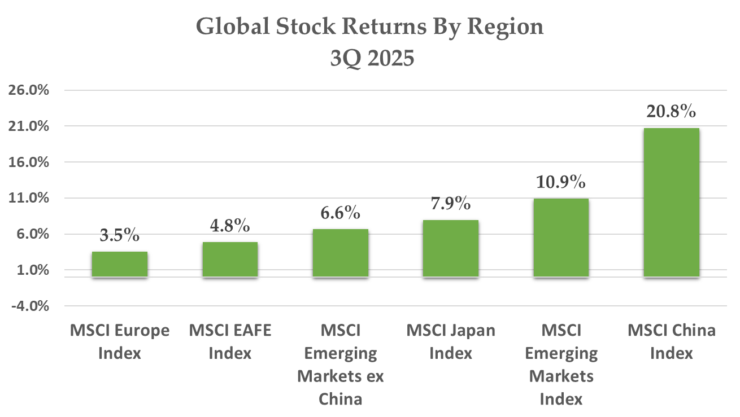
Source: Bloomberg

Fixed Income Markets

The Treasury yield curve continued its “Bear Steepener” trend during the third quarter, with short rates continuing to drop in anticipation of Federal Reserve rate cuts while intermediate and longer term yields holding steady.

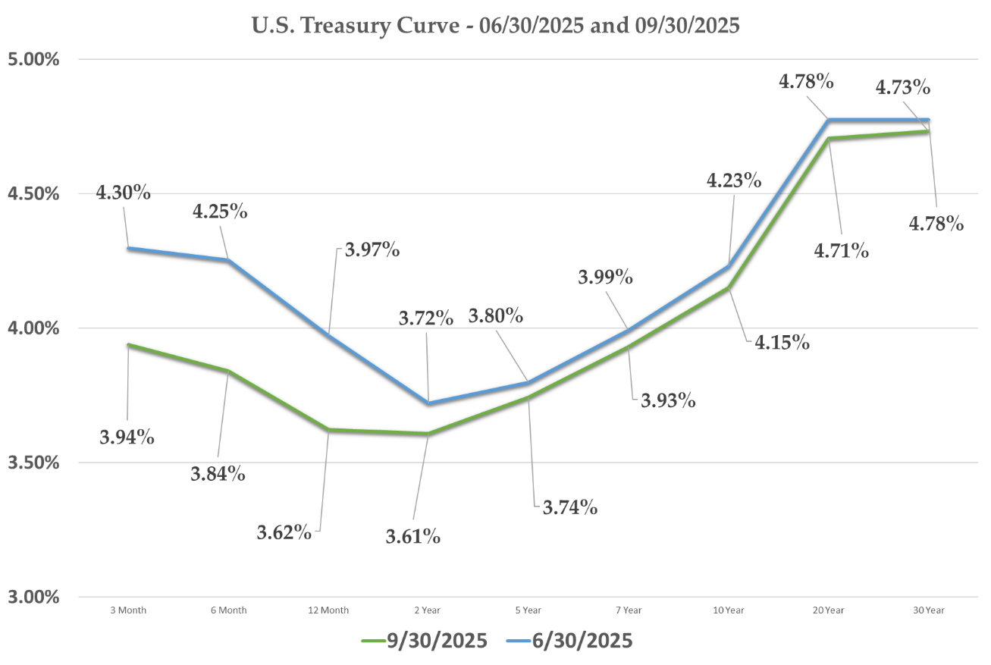
Source: Bloomberg
We have discussed previously the Federal Reserve’s struggle to balance its dual mandate of stable prices and full employment, with recently resurgent inflationary indicators tying its hands despite signs of a labor market slowdown. Hiring and unemployment data showed further deterioration through the summer, however, and previous job reports were revised downward to reflect a much more pronounced slowdown in the job market starting in the first months of the year. The Federal Reserve enacted a quarter point rate cut during its September meeting and adjusted its dot plot interest rate forecast to reflect greater probability of further rate cuts over the near-term.

Pondering an Artificial Intelligence Bubble

The torrid performance of AI related stocks during the quarter, primarily based on increasingly large capital expenditures that are not currently funded and do not have a clear near-term payoff, once again stoked fears of a financial bubble in this section of the stock market. The internet search term “AI Bubble” exploded in volume through the third quarter per Google Trends. The Bank of American Fund Manager survey showed a majority of respondents agreeing that we are currently in an AI Bubble. Tech luminaries ranging from Bill Gates to Jeff Bezos to OpenAI founder Sam Altman all went on record during the quarter stating that we are indeed in an AI Bubble, and many investors will experience significant losses as a result.

Given this widespread concern, it is helpful to explain the most common definition of an asset pricing bubble and map how the current backdrop fits with that model. While there is no universally accepted academic definition of an asset bubble, most adopt the early 20th Century work of economist Hyman Minsky that was refined and documented in Economic Historian Charles Kindleberger’s 1978 book “Manias, Panics, and Crashes: A History of Financial Crises.” The book breaks down historical asset bubbles into component parts and establishes a repeating cycle that occurs both due to human psychology and the excess flow of funds into low-returning or value destroying projects. It goes as follows:

Phase | Description
- New opportunity | Technological advancements drive investor interest in new profit opportunities
- Financing underwrites broad based investment | Banks, private capital, and venture funds spur excessive investment in multiple ventures.
- Investor Euphoria | Fear of Missing Out (“FOMO”) drives broad-based chasing of trends by both retail and institutional investors
- Smart Money Exits | Valuation-conscious investors book profits due to concern over elevated market prices
- Liquidity dries up. Financial distress sets in. | Mometum reverses, funding is curtailed, and investors suffer losses due to insolvency or lack of return on capital to justify initial investment.
The AI trade clearly meets the first three conditions.

- This new technology is backed by nearly messianic expectations of transforming global commerce, upending traditional industries, and spurring widespread shifts in the labor market.

- Funding for AI projects has reached unprecedented levels. Hundreds of billions have been spent by venture capitalists seeding AI startups. Corporate investment across power generating utilities and datacenter expansion is forecast at $4 Trillion dollars over the next five years.

- Valuations have become historically extreme for both public and private investments. Bay Area startup Safe Superintelligence Inc. was funded at a $30 Billion valuation despite having no product, no business plan, and no near-term goals for revenue generation. Leading AI stocks such as Palantir trade at 250x estimated earnings and 125x sales.

As of now, there is no sign of investors booking profits due to valuation concerns, nor is there any sign of slowing funding. Still, many market analysts struggle to model out future profit scenarios that can justify the current round of investment. Investors seem rational in viewing the current state of Artificial Intelligence market as a bubble, but the timing of any negative shock to AI stock valuations, as in all other historical episodes, remains uncertain.

Investment Strategy

At a time of elevated uncertainty and richly valued stock markets, we continue to play defense by rebalancing into longer-term allocations, culling back winning stocks, and making sure cash and fixed income allocations are fully funded.

Risk markets appear currently both technically stretched and expensive compared to history. The S&P 500 Index currently trades at 25x its forward earnings estimates, a 45% premium to its longer run average. Technical indicators such the VIX Curve and the percentage of stocks trading above their 50-day moving average are showing historically elevated readings.

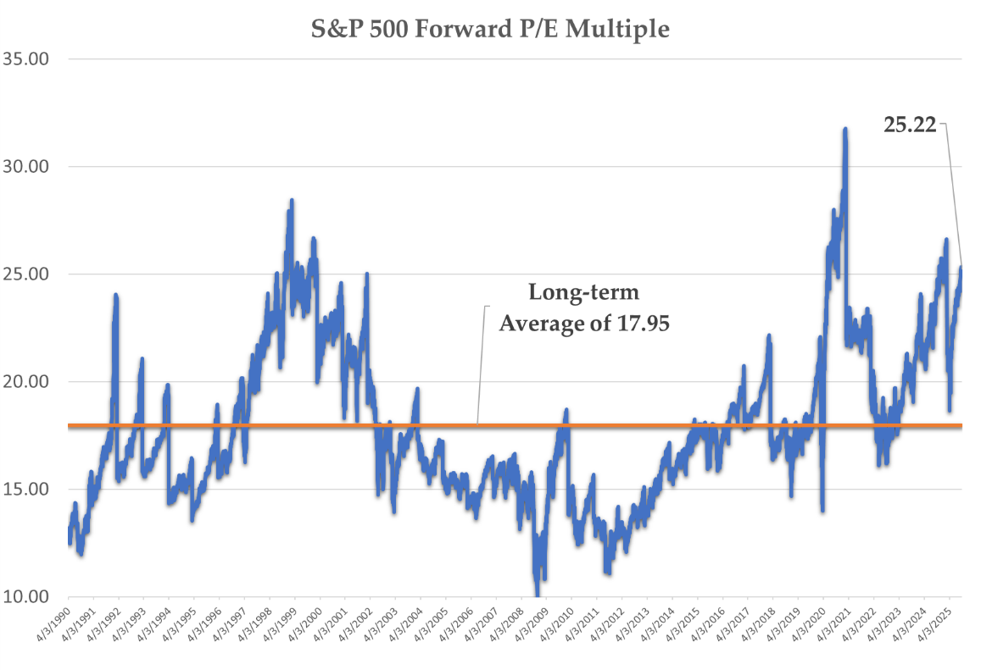

These conditions exist during a period of slowing economic growth, a wobbling job market and geopolitical concerns ranging from a U.S. government shutdown to the ongoing trade war. Investors should not be surprised by any near-term drawdown in stock markets if the potential downside from these factors creeps into corporate data.

For longer term, buy-and-hold investors, the backdrop looks less ominous. The Federal Reserve’s switch to a more accommodative monetary policy should alleviate some of the pain from higher borrowing costs. The economy, while slowing, remains in good health by any longer-run standard. Corporate managers have navigated recent tariff uncertainty with a deft touch with earnings growth remaining strong, and forecasts continue to point to near-term growth. Any stock correction should be looked to opportunistically.

While frothy valuations in sections of the stock market are a legitimate concern, we shared the previous graph on cyclical and defensive performance to illustrate how many sections of the stock market sport more sober or even attractive valuations, and a properly diversified portfolio should weather any storm posed by a drawdown in AI related investments.

Investors should maintain diversification discipline with an eye to the long-term, even if certain strategies have not kept pace with the historically abnormal returns of the last few years in tech and communications investments.

We see no change in the current trend in fixed income markets. Yields on cash should drift lower over the next year so idle funds parked at banks or even money market funds should be redirected to higher yielding bonds if possible. Extending maturities to lock in yields now remains a smart move.

We look forward to discussing these comments, or any other question or concern, with you soon. As always, we appreciate the trust and faith you place in our firm.

Sincerely,

TURTLE CREEK TRUST

“Turtle Creek Trust Company, LTA, is a chartered trust company registered with the State of Texas. Turtle Creek Management, LLC, is an investment adviser registered with the United States Securities and Exchange Commission. Turtle Creek Management, LLC, is not a chartered bank, trust company, or depository institution. It is not authorized to accept deposits or trust accounts and is not licensed or regulated by any state or federal banking authority. Turtle Creek Trust Company, LTA, and Turtle Creek Management, LLC, are wholly owned subsidiaries of TCTC Holdings, LLC, which together operate under the assumed name Turtle Creek Trust.”

