January 2026

Dear Turtle Creek Client,

U.S. stocks advanced slightly during the fourth quarter, building on strong year-to-date gains and exhibiting a general broadening of stock returns that had previously relied almost completely on Artificial Intelligence related stocks through the first nine months of the year. International markets also posted positive results during the period while interest rates were flat for the quarter.

Turtle Creek Trust entered 2025 on a cautious note, fretting over mounting geo-political and inflationary risks, premium stock valuations, and the potential for irrational exuberance in the Artificial Intelligence trade. This stance initially proved wise, with markets falling nearly 15% through April as the scale of Trump Administration’s trade measures caught markets’ flat-footed and greatly increased recessionary expectations. These recessionary and inflationary risks failed to materialize, however, as the Trump administration ultimately backtracked on its most punitive trade measures. Stocks also enjoyed several tailwinds throughout the year including fiscal stimulus from the recent congressional budget and a more accommodative Federal Reserve that cut rates twice during the fourth quarter. Corporate profits ultimately showed great resilience throughout the year, and markets staged a sustained rally off their early April lows.

Looking forward, market analysts and corporate executives continue to show great optimism. Earnings forecasts call for double-digit growth through the upcoming year, and Analyst S&P 500 targets also call for another year of double-digit market gains in 2026. As Turtle Creek Trust is a firm that prefers to be greedy when others are fearful and vice versa, this near universal optimism in the face of many still relevant market risks gives us pause. We continue to emphasize our Bear Market playbook at this juncture, urging clients to maintain appropriate diversification, cull back winners in a tax sensitive manner, and make sure all near term obligations are fully funded.

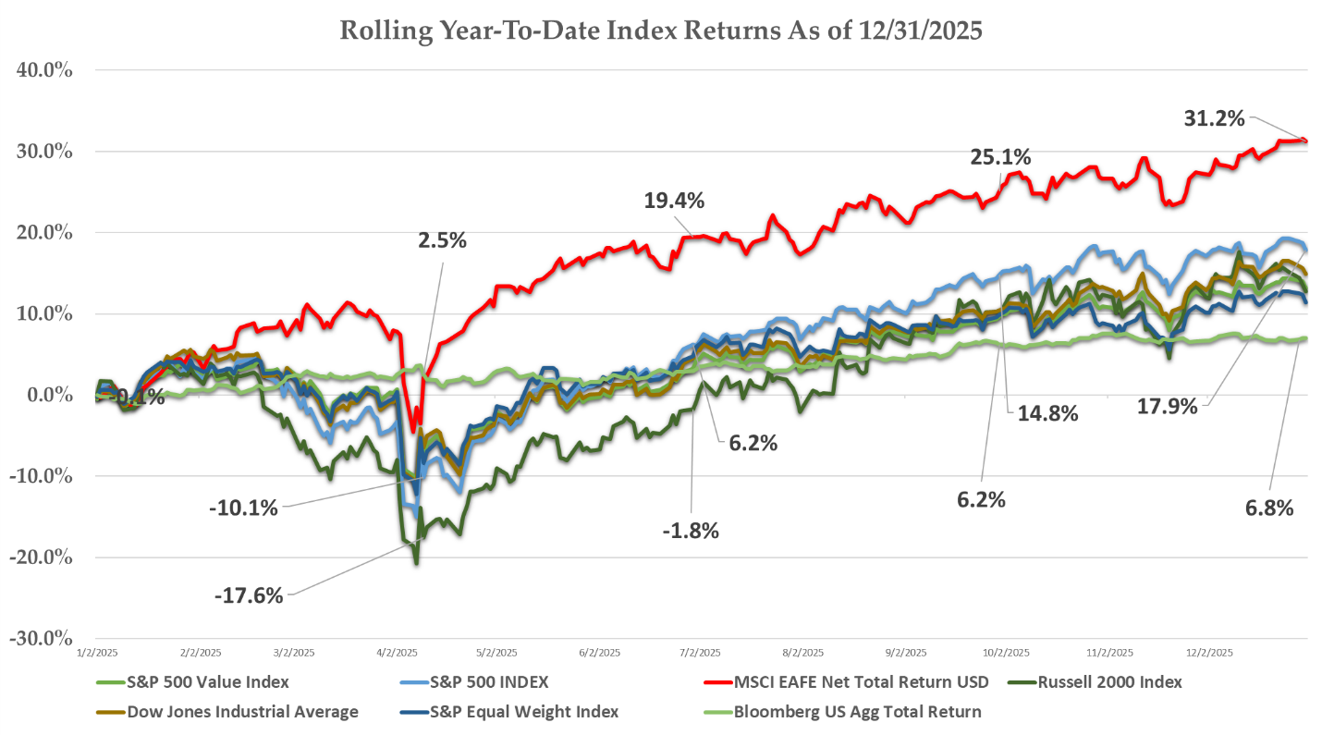
Source: Bloomberg

Fourth Quarter and Full Year Stock Market Performance

U.S. stocks (as measured by the S&P 500 Index) advanced 2.7% for the quarter, pushing full year gains to 17.9% by year end. Nearly all economic sectors posted positive results. Health care stocks were the biggest market winners, advancing nearly 12% as many downtrodden pharmaceutical stocks posted strong double-digit gains due to a less punitive regulatory outlook for drug pricing and strong earnings results. Communications stocks also lead the overall market, entirely due to Alphabet (Google) shares jumping nearly 30% during the period. Its Gemini AI engine made huge strides during the quarter, headlined by a global licensing agreement with Apple to power its Siri voice assistant on Apple products.

Real Estate and Utilities stocks posted losses for the period. These rate sensitive stocks had traded up through the summer in anticipation of a Federal Reserve easing cycle. Hopes for further Fed rate cuts were dashed in the fourth quarter, however, as hiring and inflationary data came in stronger than expected. Rate sensitive stocks sold off in sympathy.

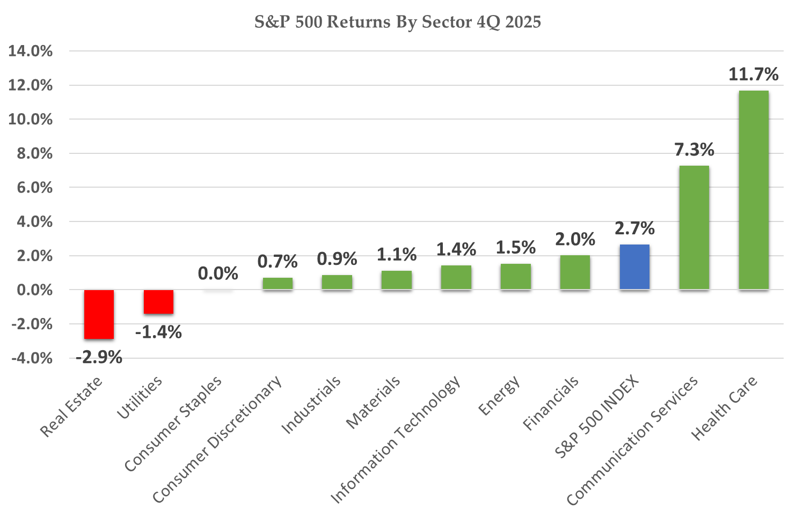
Source: Bloomberg

International stocks continued their torrid advance through year end, with most every global region outperforming U.S. markets. European shares jumped 6% in the quarter, with the European Utility, Financial, and Health Care sectors all advancing by more than 10% during the period. Emerging market stocks posted a 4.7% gain despite noticeable weakness in Chinese shares. The Chinese economy produced a series of weak economic reports displaying stagnating industrial production and weaker than expected retail spending. Those datapoints along with profit taking in technology and communications shares resulted in a 7.6% decline for China shares during the quarter. Even with China weakness at year end, international shares posted banner results with most every region gaining more than 30% during 2025. Japan shares were the worst performer with a still impressive 25% gain.

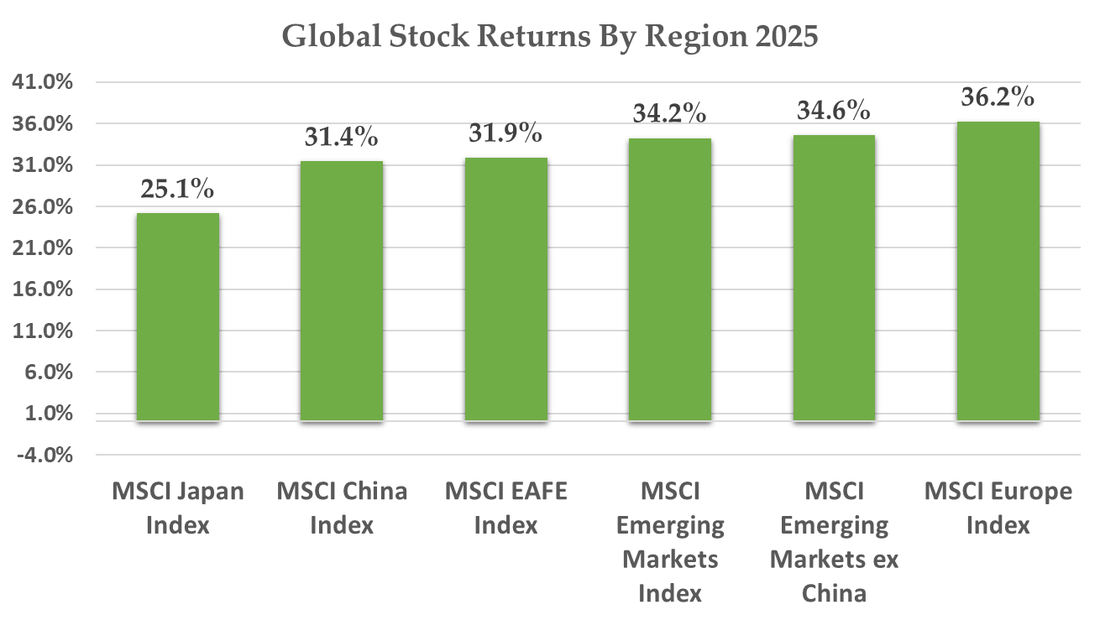
Source: Bloomberg

Fixed Income Markets

Interest rates gyrated through several volatile phases during 2025 but settled into a narrow range through the fourth quarter. The benchmark 10 Year Treasury yield began the year on a steep climb as inflationary concerns pushed traders to dump government bonds. The sudden shock of the Trump trade war caused a steep reversal in yields during February, however, as recessionary worries overtook the bond market and investors piled into the relatively safety of bonds. Rates reversed once again in April as investors reassessed the chances of recession and inflation, only to collapse yet again starting in May as the U.S. economy showed signs of weakness investors were spooked by the October government shutdown.

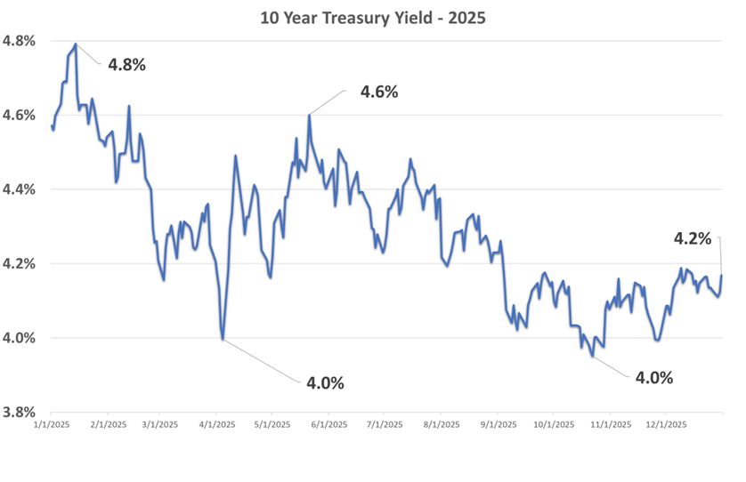
Source: Bloomberg
By year’s end, economic data settled into a more stable pattern with personal income, consumer spending, hiring, and inflationary indicators all largely meeting consensus forecasts. Inflation particularly posted milder results than expected, which resulted in the Federal Reserve dialing back expectations for further Fed Funds rate cuts over the near term. The 10 Year Treasury Yield finished the fourth quarter almost precisely where it began at 4.17%.

The total return for bond indices during 2025 favored intermediate and longer-duration strategies, as those benefitted the most from the overall decline interest rate across the yield curve throughout the year.

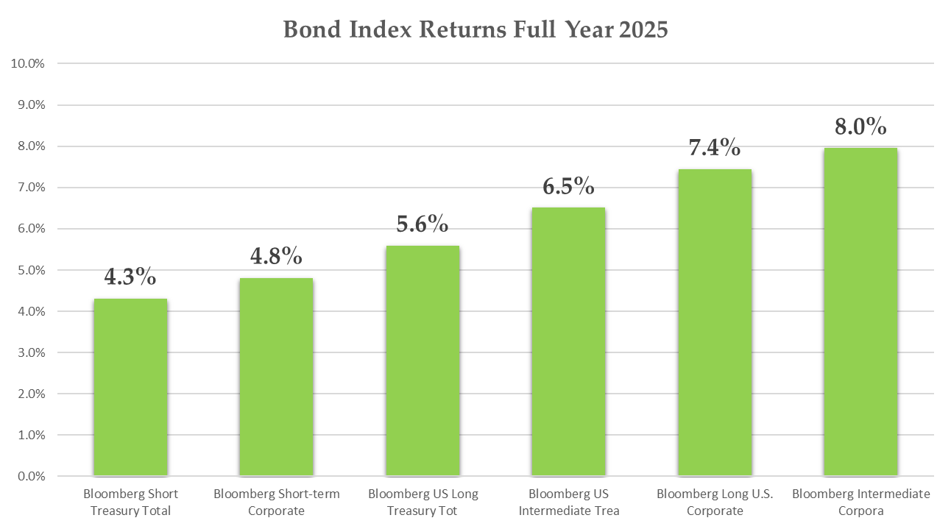

Source: Bloomberg
Lessons from the 2025 Market Year

Every year, Turtle Creek Trust highlights data-points that underscore important investor lessons, and the clear choice this year is the importance of portfolio diversification. Diversification has become almost a dirty word over the last 10 years, as ownership of anything other than large cap growth and momentum stocks limited equity returns while theoretically stable, defensive asset classes such as fixed income actually amplified portfolio volatility during the interest rate spike of 2021.

Diversification is a frustrating concept for investors due to its unpredictable timing, frequency, and ease of implementation. Its benefits are calculated over multiple decades while investors are still frustratingly prone to measuring its benefit over a handful of years. The benefits of diversification assert themselves quickly in brief periods of powerful outperformance. Most importantly, there is no clear way to predict when or why its benefits might appear. Legions of alternate investment platforms and tactical asset allocation firms try in vain to quickly shift portfolio holdings to capture these benefits. None has shown consistent skill, a core reason Turtle Creek Trust emphasizes strategic rather than tactical allocation.

All of these facts were on display in 2025. Investors who increasingly bemoaned their underperforming international allocations benefited greatly from them during the year. Diversified portfolios exhibited superior risk adjusted returns most acutely during the market sell-off of February. Regarding implementation, most market analysts are still attempting to explain the significant outperformance of international stocks amidst a backdrop of heightened geo-political turmoil. Finally, diversified portfolios sometimes work in harmony as they did this year, providing investors with the best of both worlds.

Investment Strategy

Looking forward to 2026, Turtle Creek Trust acknowledges the current momentum on display in the global economy while once again reiterating the many near-term risks to your investment assets.

Market analysts, according to the numbers, are very optimistic about the future. S&P 500 earnings are currently projected to expand at a 13.7% annualized pace over the next three years. Wall Street strategists on average predict the index to finish at 7,555 by year end 2026, implying a 10% gain from its recent year end close. Rates forecasters have similarly optimistic outlooks, predicting another round of Fed rate cuts in the upcoming year while projecting longer rates to stay steady over the next few years. Should this come to pass, investors will continue to enjoy the best of both investment worlds for the foreseeable future.

But understanding such forecasts are often incorrect, we do wonder what lurking risks could derail this potentially wonderful outcome. To paraphrase Franklin Delano Roosevelt, the only fear is usually lack of fear itself. Market sentiment is buoyant at the moment, as displayed by the ongoing elevated valuation multiples in broad market indices. The S&P is trading at 25x its forward EPS estimate.

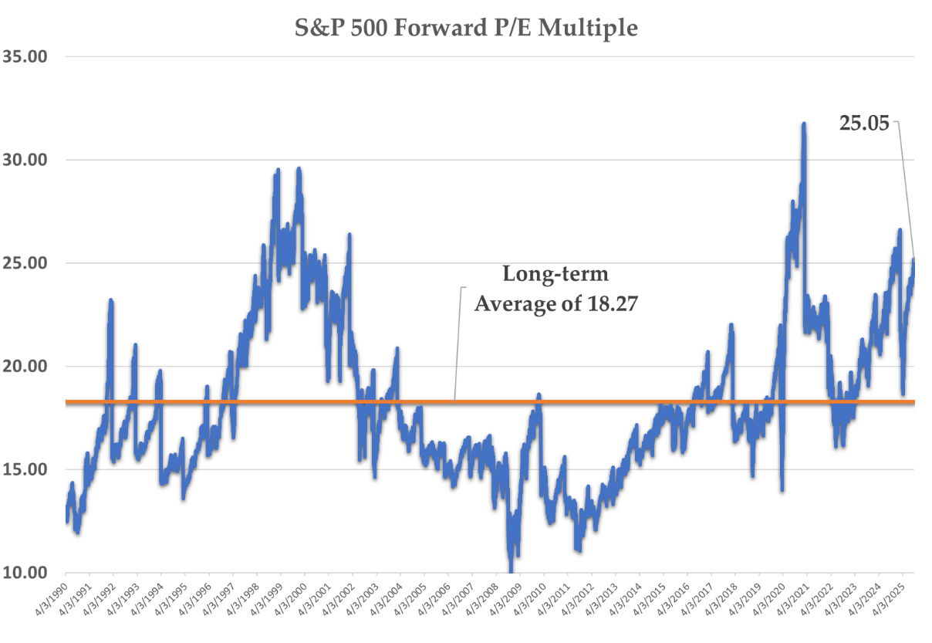
Source: Bloomberg

Much of this historically extreme valuation is embedded in large cap technology and communications firms currently benefitting from the unprecedented investment in Artificial Intelligence capabilities. Considering this, we once again state our views that episodes of techno-optimism such as the current AI frenzy can and often do end in investor disappointment, and this time might not be different.

Additionally, we recognize that markets have prospered during this recent stretch of elevated geo-political uncertainty, but we still don’t discount that trade wars have historically been a net negative for both the American economy and the stock market. Any fallout from Washington policy bears close watching.

We always counsel our clients to fix the roof while the sun is still shining, and the sun is rarely brighter than at this moment. This implies that you continue to heed the lessons of diversification that were on display this year, reducing any concentration in the growth-oriented investments that have grown over the past few years while maintaining adequate exposure to less richly valued segment of the global economy.

In terms of rates, we continue to struggle to handicap the path of short and intermediate term rates over the near term. Inflation has been in check despite Washington policy, and most options markets agree that the Fed will continue to cut over the next year, extending the recent “bull steepener” trend of short-term rates falling while intermediate rates stay fixed. In that scenario, it continues to be wise to extend maturities of bond holdings in your portfolio.

Even if markets do not meet the lofty expectations over the near-term, we maintain faith in their potential over the long-term, and counsel investors with longer time horizons to stay the course as always.

As always, we appreciate the trust and faith you have placed in our firm. We look forward to discussing these topics, or any questions or concerns, with you in the months ahead.

Sincerely,

TURTLE CREEK TRUST

“Turtle Creek Trust Company, LTA, is a chartered trust company registered with the State of Texas. Turtle Creek Management, LLC, is an investment adviser registered with the United States Securities and Exchange Commission. Turtle Creek Management, LLC, is not a chartered bank, trust company, or depository institution. It is not authorized to accept deposits or trust accounts and is not licensed or regulated by any state or federal banking authority. Turtle Creek Trust Company, LTA, and Turtle Creek Management, LLC, are wholly owned subsidiaries of TCTC Holdings, LLC, which together operate under the assumed name Turtle Creek Trust.”

